Student Performance Prediction System

Project Id: AIML-5

Name : SHRESTH VARDHAN(Team Leader)
Class Roll Number:69
University Roll Number : 2028853
Section and Group: K(G2)

Name : RAKSHIT NATH
Class Roll Number:67
University Roll Number : 2028816
Section and Group: K(G2)

Name : MOHAMMAD FAIZAL
Class Roll Number:54
University Roll Number : 208767
Section and Group: K(G2)

TABLE OF CONTENTS
- Problem Description 3
  - Dataset Description 3
  - Flow diagram 4
- Modules for Project Implementation…………………..…………………………5
  - Modules Used 5
  - Platform Used 6
- Machine Learning model/ Searching Technique used 7
- Evaluation metrics used 8
- Results and Visualizations 9
- Conclusion and Future Scope 11
- References 12

- Problem Description
The Student Performance Prediction System is a machine learning-based application designed to analyse and predict outcomes based on user behaviour data. In this project, the system uses keystroke dynamics data, which captures typing patterns such as key press duration and time intervals between keystrokes.
Traditional methods of identifying users or a performance often rely on manual observation or static data, which can be time-consuming and less accurate. This project addresses that limitation by applying automated machine learning techniques to process large amounts of data efficiently and accurately.
The system performs several key tasks:
- Collects and preprocesses raw keystroke data
- Removes irrelevant or non-numeric information
- Trains multiple machine learning models on the dataset
- Evaluates and compares model performance using standard metrics
- Uses an ensemble approach (Voting Classifier) to improve prediction accuracy
The main objective of this system is to classify and predict user identity or behaviour based on typing patterns. This has practical applications in:
- User authentication systems
- Behavioural biometrics
- Security and fraud detection
By leveraging machine learning algorithms and data preprocessing techniques, the system provides a reliable and efficient solution for pattern-based prediction tasks.

1.1 Dataset Description

The dataset used in this project is keystroke.csv, which contains numerical features representing user typing (keystroke) behaviour. This type of data is commonly used in machine learning for user identification and classification tasks.
Each row in the dataset represents a single observation of typing activity, while the columns represent different features such as:
- Key press duration
- Time interval between consecutive key presses
- Typing speed-related attributes

During preprocessing:
- All non-numeric values (such as user IDs like s011) are removed
- The dataset is cleaned to ensure only meaningful numerical data is used
- The last column is considered as the target variable, representing the class/label to be predicted
The dataset is then divided into:
- Feature set (X): All input variables
- Target variable (y): Output class
This structured dataset is used to train multiple machine learning models to classify user behavior based on typing patterns.

1.2 Flow Diagram

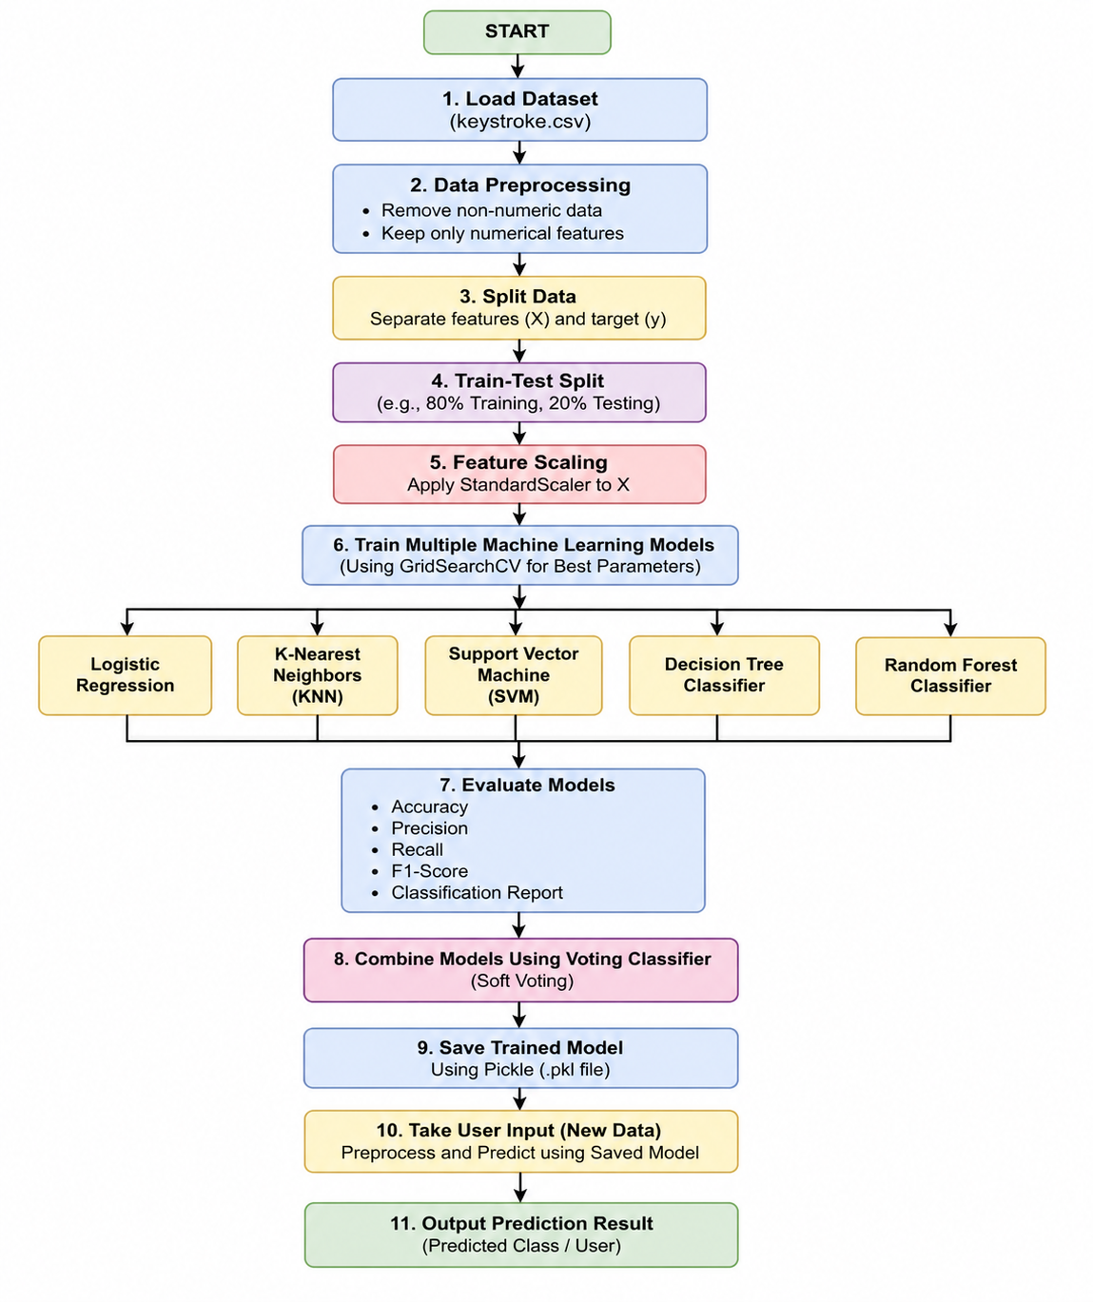

2.1 Modules Used :
1. Pandas
Used for data loading and manipulation
- pd.read_csv() – Load dataset
- df.select_dtypes() – Select numeric data

2. NumPy
Used for numerical operations
- np.array() – Create arrays
- np.unique() – Check unique values

3. Scikit-learn
Model Selection:
- train_test_split() – Split dataset
- GridSearchCV() – Hyperparameter tuning
Preprocessing:
- StandardScaler() – Feature scaling
Models Used:
- LogisticRegression
- KNeighborsClassifier
- SVC (Support Vector Machine)
- DecisionTreeClassifier
- RandomForestClassifier
Metrics:
- accuracy_score()
- precision_score()
- recall_score()
- f1_score()
- classification_report()

4. Pickle
Used for saving trained models
- pickle.dump() – Save model
- pickle.load() – Load model

2.2 Platform Used:
Visual Studio Code (VS Code)
Visual Studio Code was used as the primary development environment for writing, editing, and debugging the Python code. It provides a lightweight yet powerful interface with support for multiple programming languages.
Key reasons for using VS Code:
- Integrated terminal for running Python scripts efficiently
- Debugging tools to identify and fix errors in the code
- Support for extensions like Python extension for better code completion and linting
- Easy file management and project organization
VS Code helped in maintaining clean and structured code throughout the project development.

Jupyter Notebook
Jupyter Notebook was used for implementing and testing the machine learning models in an interactive environment. It allows execution of code in small cells, making it easier to debug and visualize outputs step-by-step.
Key advantages of Jupyter Notebook:
- Interactive coding environment for step-by-step execution
- Easy visualization of outputs such as model accuracy and results
- Ability to document code using markdown cells
- Useful for experimenting with different machine learning models and parameters
Jupyter Notebook made it easier to understand the workflow of the model and visualize intermediate results effectively.

Python Programming Language
Python was used as the core programming language for this project due to its simplicity and strong support for data science and machine learning.
Reasons for using Python:
- Easy syntax and readability
- Large number of libraries such as Pandas, NumPy, and Scikit-learn
- Strong community support
- Efficient handling of data and machine learning tasks

3. Machine Learning Model/ Searching Technique Used
1. Logistic Regression
Logistic Regression is a supervised learning algorithm used for binary classification. It predicts the probability of a data point belonging to a particular class using a logistic (sigmoid) function. It works well for linearly separable data.

2. K-Nearest Neighbors (KNN)
KNN is a distance-based algorithm that classifies a data point based on the majority class of its nearest neighbors. It is simple and effective for small datasets but can be slower for large datasets.

3. Support Vector Machine (SVM)
SVM is used for classification by finding the optimal hyperplane that separates data into different classes. It works well for both linear and non-linear data using kernel functions.

4. Decision Tree
Decision Tree is a tree-based model that splits the dataset into branches based on feature values. It is easy to understand and interpret but may overfit if not controlled.

5. Random Forest
Random Forest is an ensemble learning method that combines multiple decision trees to improve accuracy and reduce overfitting. It provides better performance than a single decision tree.

6. Voting Classifier
Voting Classifier combines predictions from multiple models and gives the final output based on majority voting or probability (soft voting). It improves overall model performance and accuracy.

7. GridSearchCV (Searching Technique)
GridSearchCV is used for hyperparameter tuning. It searches for the best combination of parameters for each model by testing multiple values and selecting the one that gives the best performance.

4. Evaluation metrics used:

1. Accuracy
Accuracy measures the overall correctness of the model by calculating the ratio of correct predictions to total predictions.
$$Accuracy=\frac{TP+TN}{TP+TN+FP+FN}$$
Where:
TP = True Positive, TN = True Negative, FP = False Positive, FN = False Negative

2. Precision
Precision measures how many of the predicted positive values are actually correct.
$$Precision=\frac{TP}{TP+FP}$$

3. Recall
Recall measures how many actual positive cases were correctly identified by the model.
$$Recall=\frac{TP}{TP+FN}$$

4. F1 Score
F1 Score is the harmonic mean of Precision and Recall. It gives a balance between both metrics.
$$F1=\frac{2×(Precision×Recall)}{Precision+Recall}$$

5. Classification Report
The classification report provides a detailed summary of the model performance including Precision, Recall, F1-score, and Support for each class. It helps in better understanding how the model performs on different classes.

5. Results and Visualizations

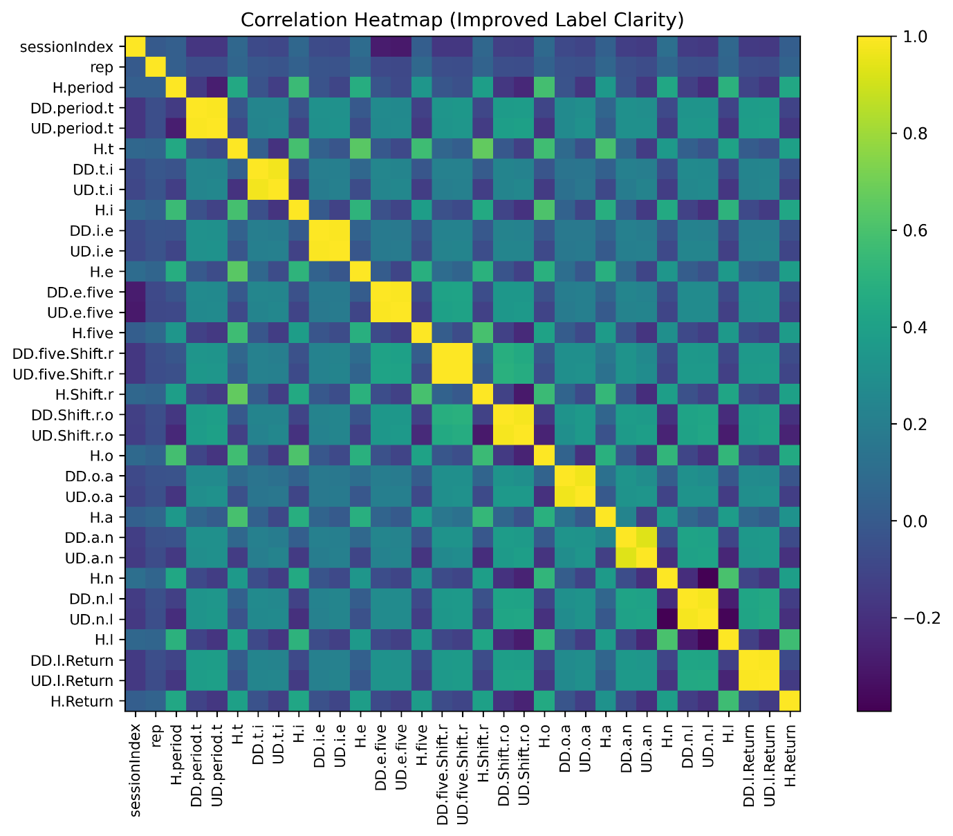

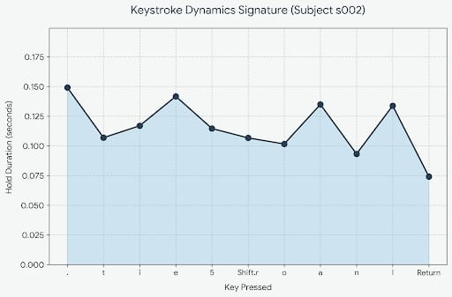

precision recall f1-score support

0 0.81 0.78 0.79 2040
1 0.79 0.82 0.80 2040

accuracy 0.80 4080
macro avg 0.80 0.80 0.80 4080
weighted avg 0.80 0.80 0.80 4080

6. Conclusion and Future Scope:
Conclusion:
The system successfully predicts student performance using multiple machine learning models. The Voting Classifier improves accuracy by combining models.
Future Scope:
- Use larger datasets for better accuracy
- Implement deep learning models
- Deploy as a web application
- Add real-time student monitoring system

7. References:
Books:
- Let Us Python – Yashavant Kanetkar

Online Resources (Based on Used Code & Libraries):
- Pandas Documentation
https://pandas.pydata.org/docs/
(Used for reading CSV and data handling – pd.read_csv)
- NumPy Documentation
https://numpy.org/doc/
(Used for numerical operations)
- Scikit-learn Documentation
https://scikit-learn.org/stable/
(Used for models like Logistic Regression, KNN, SVM, Decision Tree, Random Forest, GridSearchCV, and metrics)
- Matplotlib Documentation
https://matplotlib.org/stable/
(Used for heatmap and histogram visualization)
- Pickle Documentation
https://docs.python.org/3/library/pickle.html
(Used for saving and loading trained model)

Dataset:
- Keystroke Dataset (keystroke.csv) – Provided for project work

